<https://cloud.google.com/apis/design/>

<https://hackernoon.com/restful-api-designing-guidelines-the-best-practices-60e1d954e7c9>

**My Questions**

* What new APIs do you help to develop
* Could we expand our services to research consulting
  + Lots of scholars use this
* Possibility of event API
* What is the backend and do you anticipate this staying the same
  + What Frameworks are used

**REST APIs**

What is a REST API

* REST API is modeled as a collection of individually addressable resources (nouns of the API)

Design flow

* Determine what types of resources an API provides.
* Determine the relationships between resources.
* Decide the resource name schemes based on types and relationships.
* Decide the resource schemas.
* Attach minimum set of methods to resources.

REST API- These are standard methods that expose a lot of data

* GET: retrieve resources
* POST: create resources
* PUT: update resources
* DELETE: delete resources
* OPTIONS − Used to get the supported operations on a resource.

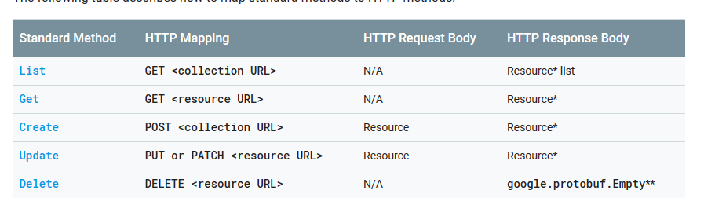

Handling Errors

* HTTP defines over 40 standard status codes that can be used to convey the results of a client’s request. The status codes are divided into the five categories presented here:
* 1xx: Informational - Communicates transfer protocol-level information
* 2xx: Success -Indicates that the client’s request was accepted successfully.
* 3xx: Redirection - Indicates that the client must take some additional action in order to complete their request.
* 4xx: Client Error - This category of error status codes points the finger at clients.
* 5xx: Server Error - The server takes responsibility for these error status codes.

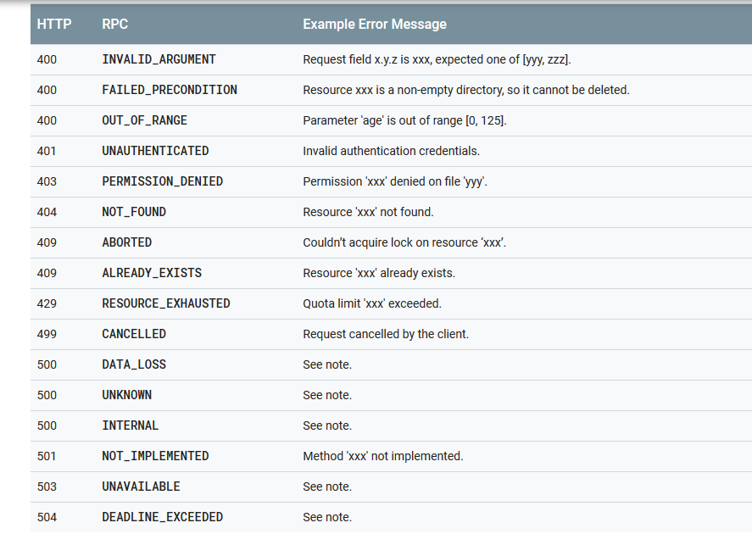

**Things I Want to Do**

Continue to build out events API

Develop documentation for non-technical users

**OSU Enterprise Services**

Enterprise Computing Services

* Empowering and integrating OSU's business data systems

The Data Architecture Team (DATA)

* Serves as the group responsible for the development and improvement of RESTful APIs that use proven standards, design patterns and data formats.
* DATA focuses on improving the interoperability of applications to streamline communication between systems and provide a platform so that data can be leveraged by services provided to students, staff and faculty at OSU. Any developer at OSU can take advantage of the available APIs to implement into their programs. Check out our developer resources and connect with the developer community at Oregon State.

## Open Source Lab

The [Open Source Lab (OSL)](http://osuosl.org/) began in 2002 and supports the Open Source community by providing co-location, managed hosting and cloud solutions to academic and industry partners.

The lab runs multiple data centers with approximately 400+ physical servers, 200+ virtual machines with FTP/HTTP software mirroring services in Corvallis, Chicago and New York. The lab delivers more than 430 terabytes of information every month for our customers.

In support of our mission the lab currently hosts over 150 medium to large high impact Open Source projects including:

* Apache Software Foundation
* Linux Foundation
* Python Software Foundation
* Drupal.org
* Debian
* Gentoo

In addition, we are also expanding our offering to include a variety of SaaS and PaaS solutions (e.g., various web platforms, Mailman, Database as a service, OpenStack instances), to meet the needs of our customers.